 | 

SOFTWARE CONSTRUCTION
Phase 1: Inception
Initial Proposal Report

Submitted By: 1. Hamza Haider (454989)
2. Hassnain Bin Nisar (456079)
3. Maaz Ahmad (469539)
4. Ahtisham Arif (460560)
5. GC Zaeem Sajid (486850)
6. GC Tayyab (486856)

Submitted To: Lec Fawad Khan

Course: BESE 29-A

Date: 15th Oct, 25

Phase 1: Inception / Initial Proposal Report
Project Title: Intelligent Air Quality Index Monitoring and Notification System

1. Background and Context
Air pollution has emerged as a major environmental and public health challenge in Pakistan. Cities like Lahore and Karachi frequently rank among the most polluted in the world. Lahore has recorded AQI levels exceeding 400 during peak smog season, placing it in the “hazardous” category. Karachi, Pakistan’s largest industrial and port city, suffers from persistent pollution caused by traffic congestion, industrial emissions, and poor waste management.
This is not just an environmental concern; it is a national health crisis. Millions of Pakistanis are exposed daily to unsafe air, leading to increased cases of asthma, lung infections, heart disease, and reduced life expectancy. The economic impact is also severe, with lost productivity, rising healthcare costs, and disruptions to daily life. Schools in Lahore have been forced to close during smog emergencies, and flights are often delayed or canceled due to low visibility.

Problem Statement
Pakistan lacks an affordable, real-time, and citizen-oriented system to monitor air quality and issue timely alerts. Existing monitoring stations are limited, public access to data is restricted, and there is no personalized notification system to help individuals make safe choices in their daily routines.

Why It Is Important to Solve
- Air pollution is Pakistan’s most urgent urban challenge, affecting health, education, and the economy.
- Citizens need timely information to protect themselves.
- Policymakers require accurate data to act quickly.
- A smart, technology-driven solution can empower people across Pakistan—from Lahore to Karachi—to live safer, healthier lives.

Key Stakeholders / Users
- General Public: Families, students, and workers needing air quality updates
- Health Sector: Hospitals and doctors preparing for pollution-related emergencies
- Government Agencies: Environmental departments and city administrations needing reliable data
- Researchers and NGOs: Studying pollution trends and advocating for cleaner policies
- Schools and Businesses: Planning activities based on safe air conditions

2. Proposed Software-Based Solution
We propose a web and mobile application that connects with IoT-based air quality sensors. These sensors will collect pollutant data and send it to a cloud server. The application will analyze this data, calculate the AQI, and display it in real time.
The system will also send Gmail notifications to users when air quality becomes unhealthy. It will include maps, charts, and an integrated chatbot to offer personalized recommendations. Users will be able to manage their accounts, update their location, and receive alerts accordingly.

3. Main Features and Expected Outcomes

Five Main Features
- Multi-User Account Management
  - Supports multiple users with individual accounts stored in a database
  - Personalized dashboards and settings for each user
- Gmail-Based Alerts by Location
  - Sends email notifications when AQI becomes unsafe in the user’s current location
  - Alerts are timely and easy to understand
- Dynamic Location Updates
  - Users can manually change their location
  - AQI data and alerts adjust based on the updated location
- Visual Data Representation
  - Displays AQI using graphs, charts, and color-coded indicators
  - Helps users understand trends and compare pollution levels
- Integrated Chatbot for Suggestions
  - Offers personalized advice based on user needs
  - Recommends actions like wearing masks, avoiding travel, or staying indoors

Expected Outcomes and Practical Use
- Personalized alerts and dashboards improve user engagement
- Gmail notifications keep users informed even when offline
- Location flexibility benefits travelers and multi-city residents
- Visual dashboards enhance awareness and decision-making
- Chatbot support provides real-time, practical guidance

4. Team Members’ Roles and Responsibilities
Role | Team Members
Analyst | Ehtisham
Designers | M. Hamza Haider, Maaz Ahmad, Hassnain Bin Nisar
Developers | M. Hamza Haider, Maaz Ahmad, Hassnain Bin Nisar, Ehtisham
Testers | Zaeem Sajid, Tayyab Hassan
Project Manager (optional) | Oversees progress, manages deadlines, ensures team coordination

5. Project Timeline (Gantt Chart Outline)
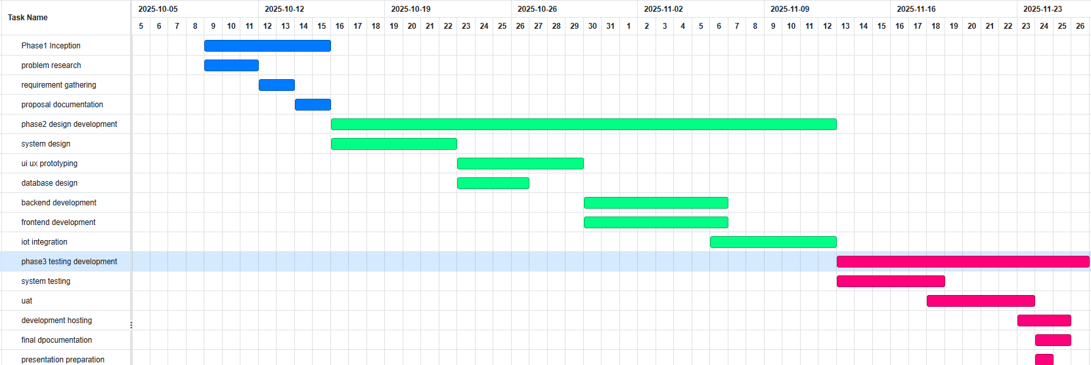

Conclusion
The Intelligent Air Quality Index Monitoring and Notification System offers a practical, affordable, and scalable solution to one of Pakistan’s most pressing problems. By combining IoT sensors, cloud computing, Gmail alerts, visual dashboards, and chatbot support, the system will empower citizens, health agencies, and governments to make informed decisions and reduce the harmful effects of air pollution.
From Lahore to Karachi and beyond, this solution has the potential to improve public health, support effective policymaking, and contribute to a cleaner, safer future for Pakistan.

